**Sprint 3 Plan**

Lost & Found

Team Rocket

Sprint Completion Date: 07/23/2018

**Goals**

*Short, 1-2 sentence description of the high-level goal(s) for the sprint.*

The focus of Sprint 3 is to unit test our components’ actions and optimize our user experience (UI clarity, convenience options, etc.)  and database calling protocols. The software will access and update the database by snapshot. Our Vue components will use universal function that handles our Firestore calls, and our calling function will potentially use asynchronous calls to update more efficiently.

**Task Listing**

*This section lists the user stories, in priority order from most important (top) to least important (bottom). Within each user story, there needs to be a list of tasks required to implement the user story, along with the time estimate for each tasks (preferably less than or equal to 6 ideal hours).*

* **User Story 1**: As a developer, I want to unit test my code to verify that it is working as expected. [2 SP] [2 hours]
  + **Task 1:** Learn how to write front-end and back-end unit tests. [1 hour]
  + **Task 2**: Write a unit test. [1 hour]
* **User Story 2:** As a user who has made a submission, I want to be able to delete my submission so that it doesn’t show up when I no longer have the item. [3 SP] [4 hours]
  + **Task 1:** Write code to allow users to delete submissions from the database. [1 hour]
  + **Task 2:** Write code to update the markers on the map when a submission is deleted. [2 hours]
  + **Task 3:** Write code to allow users to only delete/resolve their own submissions. [1 hour]
* **User Story 3:** As a user who has made a submission, I want to be able to edit this submission in the future so that I can change/add information. [8 SP] [10 hours]

*(Note: this user story was later put into the backlog after implementation difficulties and a*

*team discussion about effort vs. priority*)

* **User Story 4**: As a user who has made a submission, I want to be able to click the new marker right away to bring up the info window associated with it so that I don’t have to click refresh first. [1 SP] [1 hour]
  + **Task 1**: Integrate existing code with the user state file provided by Vuex and Firebase. [1 hour]
* **User Story 5**: As a user, I want the lost and found markers to look different so that I can distinguish between them on the map. [2 SP] [2 hours]
  + **Task 1:** Figure out how to implement functionality for custom markers instead of using Google’s default red marker. [1 hour]
  + **Task2:** Decide on what the lost and found markers should look like. [1 hour]
* **User Story 6**: As a user, I want to be able to toggle lost/found markers on and off so that I can remove clutter and better visualize what I want to see. [3 SP] [4 hours]
  + **Task 1**: Add a drop down menu to the display button in the navigation bar so that it includes a checkbox for lost markers and a checkbox for found markers. [1 hour]
  + **Task 2**: Write code so that lost/found markers only show when their checkbox is ticked, [3 hours]
* **User Story 7:** As a user, I want to differentiate between my lost and found submissions in the sidebar so that there is no confusion when I look up my previous submissions. [2 SP] [2 hours]
  + **Task 1:** Add distinct icons for lost and found items in the sidebar. [1 hour[
  + **Task 2**: Group the lost submissions together and the found submissions together. [1 hour]
* **User Story 8:** As a user, I want to be able to click on one of my submissions in the sidebar and have the map pan to that submission so that I can quickly access previous submissions and better visualize their location. [3 SP] [4 hours]
  + **Task 1:** Write code to pan the map and center on the marker that refers to the submission I click on. [2 hours]
  + **Task 2:** Write code to open the info window after the marker is panned to. [2 hours]
* **User Story 9:** As a user, I want to be able to click on a submission in the List View page and bring up the referenced marker in the map page so that I can better visualize where that item was lost/found. [3 SP] [4 hours]
  + **Task 1:** Write code to pan the map so that the marker in question is visible. [2 hours]
  + **Task 2:** Figure out how to keep the info window open after redirecting to the home page. [2 hours]
* **User Story 10**: As a user who wants to input the date in my submission form, I want to select the date from a calendar so that I don’t have to manually type it. ||1 SP| |1 hr|
  + **Task 1:** Edit the date field in the submission form to open a clickable calendar that users can use to set the date. [1 hour]
* **User Story 11**: As a user who wants to input the time in my submission form, I want to select the time from a clock so that I don’t have to manually type it. ||1 SP| |1 hr|
  + **Task 1:** Edit the time field in the submission form to open a clickable clock that users can use to set the time. [1 hour]
* **User Story 12:** As a user, I want it to be clear when I can submit an item so that I don’t click submit and end up not submitting anything. [2 SP] [2 hours]
  + **Task 1:** Indicate required fields with an asterisk. [0 hours]
  + **Task 2:** Disable the submit button when users try to submit without filling out required fields. [1 hour]
  + **Task 3:** Add animations and highlight required fields if the user attempts to submit prematurely. [1 hour]
* **User Story 13:** As a user, I want to know the character limit in the fields of the submission form so that I don’t type too much. [1 SP] [1 hour]
  + **Task 1:** Display the character limit in the fields of the submission form. [1 hour]
* **User Story 14:** As a user, I want to be able to see my own location relative to locations around me so I may have an easier time placing a marker for a lost/found item. |1 SP||1 hr|
  + **Task 1:** Create a function that displays the user’s location relative to the map using Google Maps API. [1 hour[
* **User Story 15:** As a user who is not signed in, I don’t want to profile related things to clutter up the interface. [1 SP] [1 hour]
  + **Task 1:** Remove the profile button in the navigation bar when the user is not signed in. [0.5 hours]
  + **Task 2:** Remove the toggle for opening up the side bar when the user is not signed in. [0.5 hours]

**Team Roles**

*Give a listing of all team members. Next to the team member, list their role(s) for this sprint. Assign each person to at least one role (for example, this role might be "Developer").*

* **Wan Fong**: Product Owner, Developer, Scrum Master
* **Lily Nguyen**: Developer
* **Chengyu Jiang**: Developer
* **Egan Bisma**: Developer
* **Geoff Huang**: Developer, Scrum Master
* **Peter Eskraus**: Developer

**Initial Task Assignment**

*A listing of each team member, with their first user story and task assignment.*

* **Wan Fong**:
* **Lily Nguyen**:
* **Chengyu Jiang**:
* **Egan Bisma**:
* **Geoff Huang**:
* **Peter Eskraus**:

**Initial Burnup Chart**

*A graph giving the initial burnup chart for this sprint and is labeled as such with sprint number and project name and is located in the lab.*

Note: We decided as a team to move the tasks that weren’t completed in Sprint 2 into the product backlog, so the total estimated hours went down by 5.

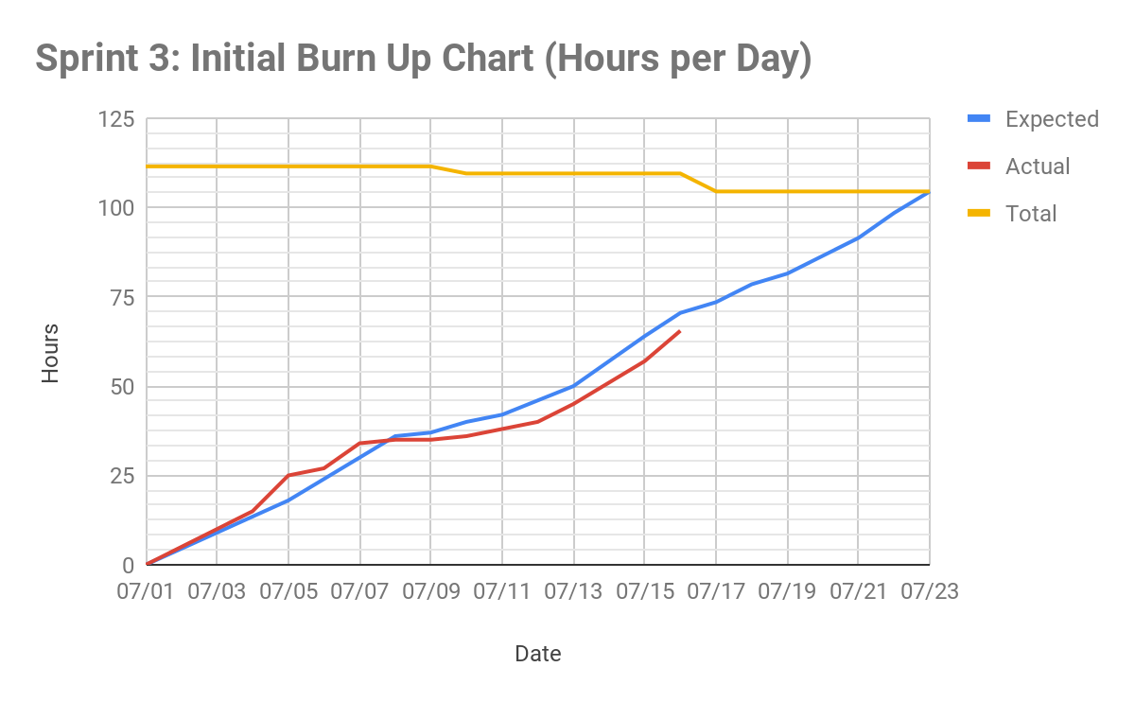

**Initial Scrum Board**

*Also known as a task board, the scrum board is a physical board and labeled as such with sprint number and project name and located in the lab. This board has four columns, titled user stories, tasks not started, tasks in progress, and tasks completed. Index cards or post-it notes representing the user stories and the tasks for this sprint should be placed in the user stories, tasks not started, and tasks in progress columns. Tasks associated with a user story should be placed in the same row as the user story.*

Our scrum board is done virtually, on Trello: <https://trello.com/b/5UmXE45n/sprint-3>

**Scrum Times**

*List at least the three days and times during the week when your team will meet and conduct Scrum meetings. Also, indicate which of these meetings will have the TA/tutor  visit as arranged with the TA/tutor. It is expected the TA/tutor will visit during the Scrum meeting during your lab time.*

Monday: 1:30 - 2:00 pm [TA present]

Wednesday: 1:30 - 2:00 pm [TA present]

Saturday: 5:00 - 6:30 pm